User Guide: Roadmap Delivery Confidence Assessment Generator

This guide walks you through using the **Streamlit app** to generate a customized PowerPoint presentation from survey data.

**STEP 1- Install Streamlit**

Open your command prompt and run: pip install streamlit

**STEP 2- Launch the App**

In the same directory as the script, run: streamlit run excelpoint.py

[Make sure you entering the .py file as it is saved in your system. Not necessary in every system it will be excelpoint.py].

This will open the app in your default web browser.

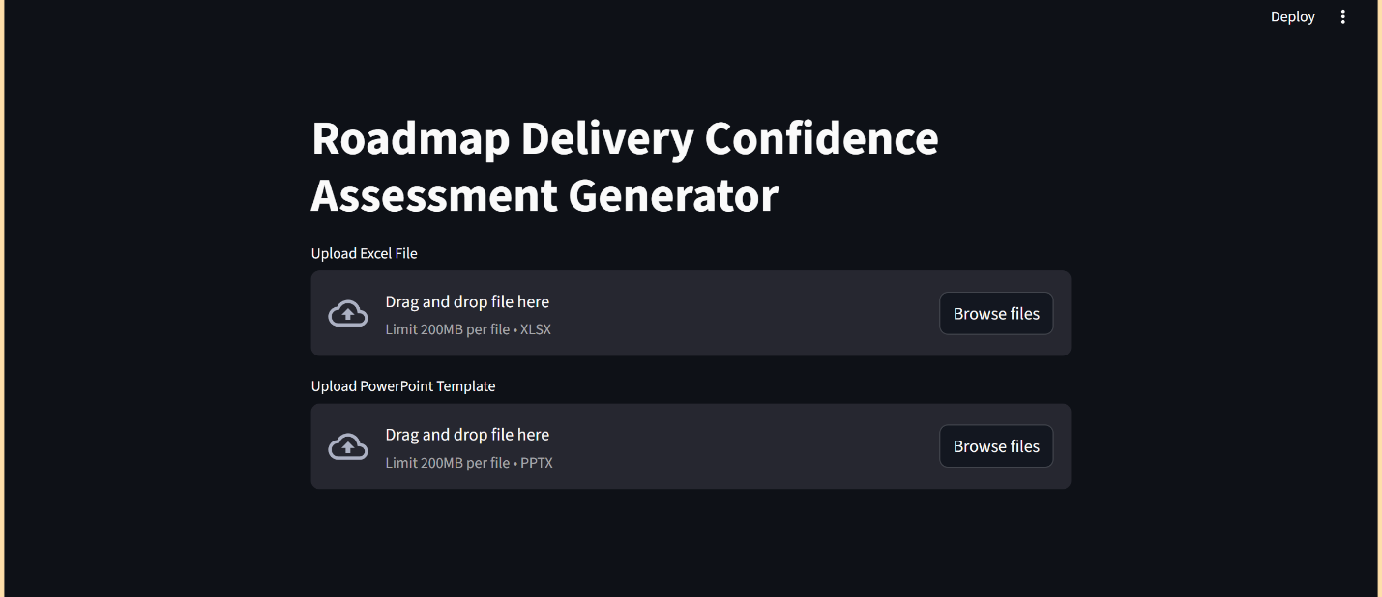

**STEP 3- Uploading Files**

Upload the mentioned Required Files:

* Excel File (.xlsx): Contains survey responses.
* PowerPoint Template (.pptx): Contains placeholder slides.

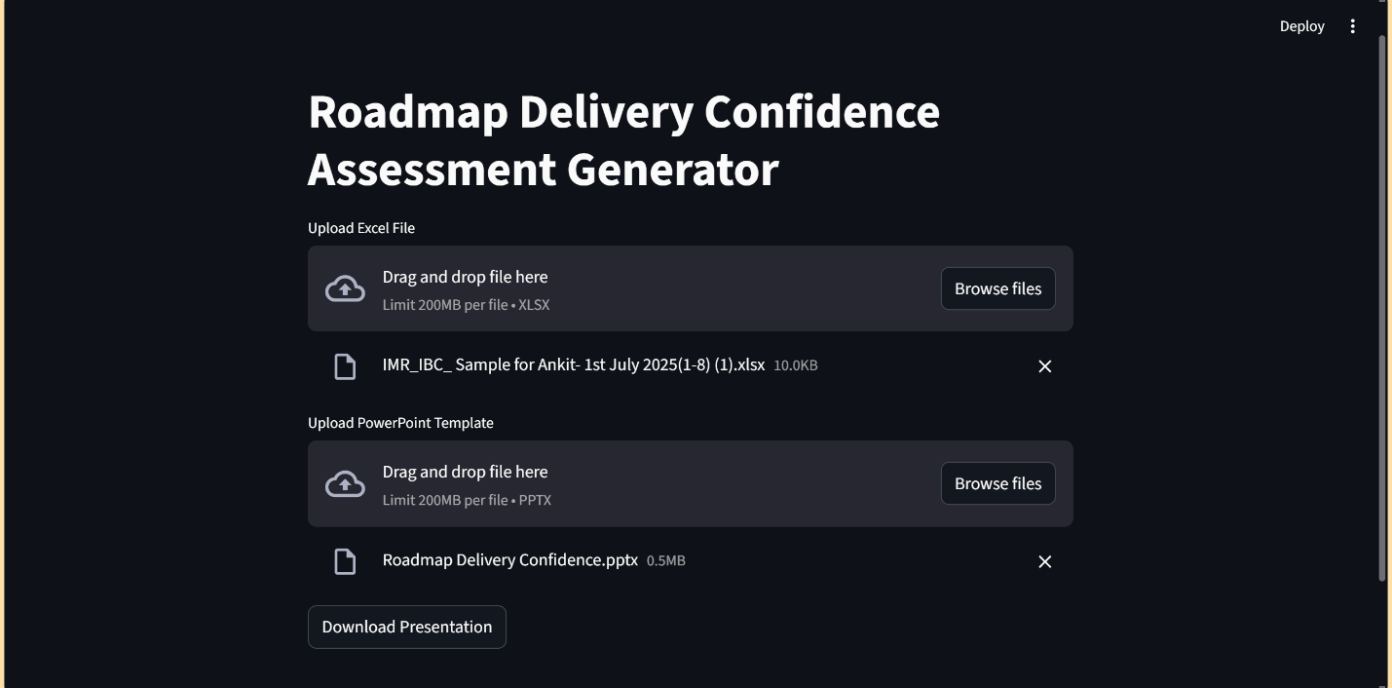

**STEP 4- Downloading the Output**

After processing, click the “Download Presentation” button to save your customized .pptx file.